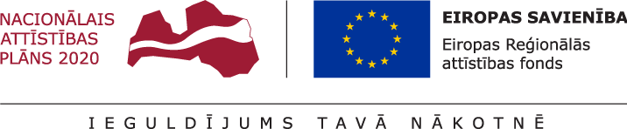

European Regional Development Fund Project Application

Project name:
Specific support goal/ measure name: | 1.2.1. specific support goal "To Increase the Private Sector Investments R&D"; measure 1.2.1.2. "Support for Improvement of Technology Transfer System"
Submitter of the project:
(research organisation)
Responsible person  (person who is entitled to represent the project submitter) | Name, Surname:
 | Telephone:
 | E-mail:
Project scientific manager | Name, Surname:
 | Telephone:
 | E-mail:
Agreement on participation in the technology transfer measure No.:
Project identification No.:
(completed by LIAA)
Project submission date:
(completed by LIAA)

When completing the project application form, please additionally see the project assessment criteria and methodology for criteria assessment!

- CONDUCTED RESEARCH AND OWNERSHIP RIGHTS OF THE RESEARCH RESULT
The right to intellectual property

- DESCRIPTION OF TECHNOLOGY
Operation of the technology and its characteristics

Technology readiness level

Novelty of technology

- MARKET
Target market

Advantages of technology

- PROJECT IMPLEMENTATION PLAN
Project application has been submitted regarding the implementation of commercialisation actions:
Performance of technical and economic feasibility study: | Jā ☐ Nē ☐
Development of commercialisation strategy: | Jā ☐ Nē ☐
- TEAM
- CONFIRMATION OF THE PROJECT SUBMITTER
By submitting the project application, I confirm that:
- information provided in the project application form is true;
- regarding the specific measure, I have not submitted a project application for receipt of financing from other funds of European Union or state support programmes;
- I have familiarised myself with terms and conditions of the respective specific support goal of the European Regional Development Fund or its measure, as well as the requirements set by the project selection;
- project shall be implemented according to the provisions of participation in technology transfer measure, CM regulations No. 692 and other regulatory enactments;
- actions regarding which the project application has been submitted have not commenced and eligible costs have not arisen prior to submission of the project application to the Investment and Development Agency of Latvia;
- project application has been submitted for the research to the intellectual property of which the project submitter has the right, including the right to use it for conducting further research or to alienate this intellectual property.

Signature:
(person who is entitled to represent the project submitter)
Date:
(dd/mm/yyyy)

- ANNEXES
..

Supported actions mentioned in Sections 33 and 34 of the CM regulations No. 692

